Assignment 2:
Suyash Damle
15CS10057

NOTE : In this case, for convenience in dealing with the dataset, the first row of the data-set, which specified the type of data in the respective coulmn has been deleted and the updated data-set in the file with the original name has been uploaded along with the reports and the code.

In this assignment, we have to determine the existence of correlation between sugar content and the rating in NUTRITION data-set. The plot of the data:
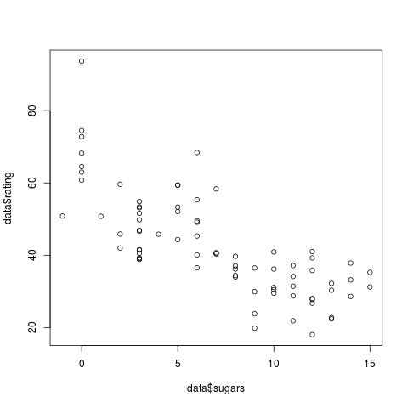
(a) Thus, from the plot of the data, it is quite clear that there is a negative relationship between the two - that is, as sugar content increases in the food, its rating falls.
In order to get a better conviction in this regard, I did the pearson test of correlation on this data (as the data is entirely numerical).
The r value from pearson test is -0.7596, indicating a strong negative correlation.

(b) To perform tests of linearity of fit, we perform the regression analysis on the dataset, with models of different order, namely linear, quadratic and cubic models.
The standard R function,

lm (Y ~ poly (X, order))

is particularly convenient to fit a data set on model of the required order.

The code output corresponding to different models is taken in terms of the R² measure of fit for each of the model, which is a measure of the extent/quality of the fit.

R² = (1 – SSE) / SST

SSE = ∑ (y_{i –} ŷ )²

SST = ∑ (y_{i –} y )²

The code outputs:

R² for linear model : 0.5771056
R² for quadratic model :0.6086492
R² for cubic model : 0.6092344

Thus, the cubic model fits the curve best.

